Name: _____________________ /50

 Yr 12 ATAR Physics EMR Test 2019

**Instructions**

1. Answer all questions in the spaces provided. If you need extra space there is a blank page at the back of the booklet – ensure you clearly indicate if you use this.
2. Give all numerical answers to three significant figures, except where you are required to estimate values where two significant figures will be appropriate.
3. Show all working – marks may be awarded for logical working even when an incorrect final answer is arrived at.
4. Up to four marks may be deducted for incorrect significant figures and / or units.

Time Limit – 50 minutes

**QUESTION ONE (4 marks)**

Todd gets a new watch for his birthday. He wears it throughout a sunny day, before carefully placing it next to his bed before he goes to sleep. Waking unexpectedly in the middle of the night Todd sees the hands and numbers on his glowing and he can clearly read the time as being 3.30am. With the aid of simple diagrams explain how and why this glowing can occur.

**QUESTION TWO (13 marks)**

The table below contains photoelectric properties collected experimentally for a range of metals.

|  |  |  |
| --- | --- | --- |
| **Element** | **Symbol** | **Work Function (eV)** |
| Potassium | K | 2.29 |
| Calcium | Ca | 2.87 |
| Scandium | Sc | 3.50 |
| Titanium | Ti | 4.33 |
| Chromium | Cr | 4.50 |
| Cobalt | Co | 5.00 |

1. Explain what is meant by the term work function as it relates to the photoelectric effect. (2 marks)
2. Calculate the maximum kinetic energy (in eV) of an ejected photoelectron when light of wavelength 338nm is shone on a piece of scandium. (4 marks)
3. When violet light of wavelength 386nm is shone on one of the metals, the stopping potential is increased until it reaches 0.350V where the photocurrent reduces to zero. Determine the work function of this metal, and then use the table to identify the most likely metal. (4 marks)
4. Explain how the photoelectric effect supports the idea that light has a particle nature. (3 marks)

**QUESTION THREE (8 marks)**

During a science activity at school, the teacher uses a green laser to highlight certain key points. Grace, sitting in the front row, notices that the laser is rated at 5.00mW and emits a wavelength of 532nm.

a) Determine how many photons per second are emitted by the laser. (4 marks)

b) Briefly explain how the laser operates to produce a monochromatic, coherent beam of light. (4 marks)

**QUESTION FOUR (17 marks)**

Murray has just started taking an interest in the night sky and has noticed that the stars are not all the same colour. Some appear red, others yellow and some white and even blue.

1. On the axes below sketch labelled graphs showing how the blackbody spectrum of a red star compares to a blue star (4 marks)



1. Use the curves you have sketched to explain why the concept of light quanta was necessary. (3 marks)
2. A tungsten bar heated to 7000C glows red. If it is heated to 27000C it will glow white. Describe the appearance of the spectra (through a spectroscope) produced by tungsten at these two temperatures. (3 marks)
3. Explain how these spectra are produced. (3 marks)
4. When viewed from the earth the Sun’s spectrum looks significantly different from a piece of metal heated and glowing the same colour. Describe the difference and explain why the difference occurs. (4 marks)

**QUESTION FIVE (8 marks)**

a) Indicate which one of the following transitions is the most energetic by circling it. (1 mark)

1. e to b

1. g to d
2. i to e

b) Determine the frequency and wavelength of the photon that would result from your answer to (a)

(3 marks)

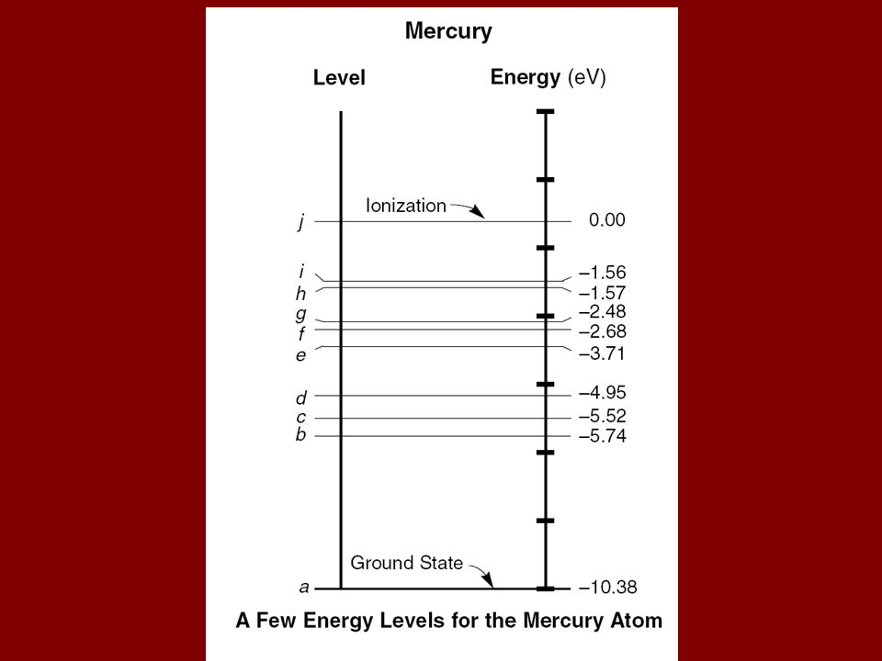

c) An electron with KE 4.70eV strikes a mercury atom and transfers some energy to an electron causing it to transition from the Ground State to the b level in a mercury atom. It then leaves the mercury atom with the remaining kinetic energy. Determine the De Broglie wavelength of the electron as it leaves the mercury atom. (4 marks)

END OF TEST